**___________________________**

**ONLINE ARTWORK BOOKING SYSTEM**

**___________________________**

**TABLE OF CONTENTS**

|  |  |  |
| --- | --- | --- |
| Chapter | Title | Page |
| 1 | Abstract | 4 |
| 2 | Introduction | 5 |
|  | 1. Project Objective | 5 |
|  | 1. Project Overview | 5 |
|  | 1. Project Scope | 6 |
| 3 | System Analysis | 7 |
|  | 1. Non Functional Requirements | 7 |
| 4 | System Design | 8 |
|  | 1. Input Design | 8 |
|  | 1. Output Design | 9 |
| 5 | Database | 10 |
| 6 | System Tools | 11 |
|  | 1. Front End | 11 |
|  | 1. Back End | 11 |
| 7 | Data Dictionary | 12-13 |
| 8 | Diagrams | 14-17 |
|  | 1. Data Flow Diagram | 14-15 |
|  | 1. Activity Diagram | 16 |
|  | 1. ER Diagram | 17 |
| 9 | Form Designing | 18-27 |
| 10 | Form Coding’s | 28-39 |
| 11 | Conclusion | 40 |
| 12 | References | 41 |

**___________________________**

**ABSTRACT**

**___________________________**

**ABSTRACT**

This project is a web based Online Artwork Booking for an existing theatre. The project objective is to book the ticket uploaded by the authorities online.

This project is an attempt to provide the advantages of booking tickets online to users in a particular theatre. It helps getting ticket details and information about movie through text message in their mobile anywhere through internet. Thus the users will get the benefit of online booking and they do not have to stand in a queue for the tickets. This system can be implemented to any gas agency in the locality.

The movie details are uploaded by the authorities of the theatre for.

**___________________________**

**INTRODUCTION**

**___________________________**

**INTRODUCTION**

This project is a web based Online Artwork Booking for an existing theatre. The project objective is to book the ticket uploaded by the authorities online.

This project is an attempt to provide the advantages of booking tickets online to users in a particular theatre. It helps getting ticket details and information about movie through text message in their mobile anywhere through internet. Thus the users will get the benefit of online booking and they do not have to stand in a queue for the tickets. This system can be implemented to any gas agency in the locality.

The movie details are uploaded by the authorities of the theatre for.

* 1. **PROJECT OBJECTIVE:**
* To make Artwork booking process easy through online.
* User should not need to stand in a queue for booking their Artwork .
* Authorities can be able to easily upload the details of movies.
* User will get their ticket details through message.

**1.2 PROJECT OVERVIEW:**

The central concept of this web application is to allow the users to book the tickets of a movie which is running in the particular theatre.

The authorized staff can upload, delete and edit the movie details with the necessary documents. No others unauthorized staff can make any changes to the upload section of the website. Each authorized staff have to make login in to this application with their Username and Password to upload or change the movie details.

**1.3** **PROJECT SCOPE:**

This system can be implemented for any particular gas agency so that they can upload movie details for the users.

It allows all users to have access website after login so that they can book tickets from anywhere and from any device. No one has to go to specific location to book the tickets. It make easy to upload movie details for theatre staff and to view the seats left for user from any location and from any device. Since the application is available in the online web it is easily accessible and always available.

**___________________________**

**SYSTEM ANALYSIS**

**___________________________**

**SYSTEM ANALYSIS**

System analysis is the process of gathering and interpreting facts, diagnosing problems and using the information to recommend improvements on the system. System analysis is a problem solving activity that requires intensive communication between the system users and system developers.

System analysis or study is an important phase of any system development process. The system is viewed as a whole, the inputs are identified and the system is subjected to close study to identify the problem areas. The solutions are given as a proposal. The proposal is reviewed on user request and suitable changes are made. This loop ends as soon as the user is satisfied with the proposal.

**NON FUNCTIONAL REQUIREMENTS**

1. **N.1: Platform:**

This software is web based application developed for all types of end users. It run in any device as this web application is full responsive.

1. **N.2: Database:**

The application is using MySQL database.

1. **N.3: Internet Access:**

As this application is hosted on web server, therefore internet access is required

**___________________________**

**SYSTEM DESIGN**

**___________________________**

**SYSTEM DESIGN**

System design is the solution for the creation of a new system. This phase focuses on the detailed implementation of the feasible system. It emphasis on translating design. Specifications to performance specification. System design has two phases of development

* Physical Design
* Logical Design

During logical design phase the analyst describes inputs (sources), output (destinations) and databases (data sores) all in a format that meets the user requirements. The analyst also specifies the needs of the user at a level that virtually determines the information flow in and out of the system and the data resources. Here the logical design is done by database design. The physical design is followed by physical design or coding. Physical design produces the working system by defining the design specifications, which specify exactly what the candidate system must do. The programmers write the necessary programs that accept input from the user, perform necessary processing on accepted data and produce the required report on a hard copy or display it on the screen.

**3.1 INPUT AND OUTPUT DESIGN**

* **Input Design:**

Input design is the link that ties the information system into the world of its

Users,

The input design involves determining the inputs, validating the data, minimizing the data entry and provides a multi-user facility. Inaccurate inputs are the most common cause of errors in data processing. Errors entered by the data entry operators can be controlled by input design. The user-originated inputs are converted to a computer based format in the input design. Input data are collected and organized into groups of similar data. Once identified, the appropriate input media are selected for processing. All the input data are validated and if any data violates any conditions, the user is warned by a message. If the data satisfies all the conditions, it is transferred to the appropriate tables in the database. In this project the student details are to be entered at the time of registration. A page is designed for this purpose which is user friendly and easy to use. The design is done such that users get appropriate messages when exceptions occur.

* **Output Design:**

Computer output is the most important and direct source of information to the user. Output design is a very important phase since the output needs to be in an efficient manner. Efficient and intelligible output design improves the system relationship with the user and helps in decision making. Allowing the user to view the sample screen is important because the user is the ultimate judge of the quality of output. The output module of this system is the selected notifications.

**___________________________**

**DATABASE**

**___________________________**

**DATABASE**

**Database Design**

Databases are store house of data in software system. Data are store on table

Inside the database.Serval table are created for manipulation of data in system. Two

Essential setting for database they are :

1. **Primary keys:**

The field that is unique for all the record occurrences.

1. **Foreign keys**

The field used to set relation between tables.

Normalization is a technique to avoid redundancy in the tables.

**___________________________**

**SYSTEM TOOLS**

**___________________________**

**SYSTEM TOOLS**

The various system tools that have been used in developing both the front end and the back end of the project are being discussed in this chapter.

**FRONTEND**

* **Bootstrap**

**Bootstrap** is a [free and open-source](https://en.wikipedia.org/wiki/Free_and_open-source_software) front-end [web framework](https://en.wikipedia.org/wiki/Web_framework) for designing [websites](https://en.wikipedia.org/wiki/Website) and [web applications](https://en.wikipedia.org/wiki/Web_application). It contains [HTML](https://en.wikipedia.org/wiki/HTML)- and [CSS](https://en.wikipedia.org/wiki/CSS)-based design templates for [typography](https://en.wikipedia.org/wiki/Typography), forms, buttons, navigation and other interface components, as well as optional [JavaScript](https://en.wikipedia.org/wiki/JavaScript" \o "JavaScript)extensions. Unlike many web frameworks, it concerns itself with [front-end development](https://en.wikipedia.org/wiki/Front-end_web_development) only.

Bootstrap is the second most-starred project.

**BACK END**

The back end is implemented using MySQL which is used to design the databases.

PHP as a backend server.

**___________________________**

**DATA DICTIONARY**

**___________________________**

**DATA DICTIONARY**

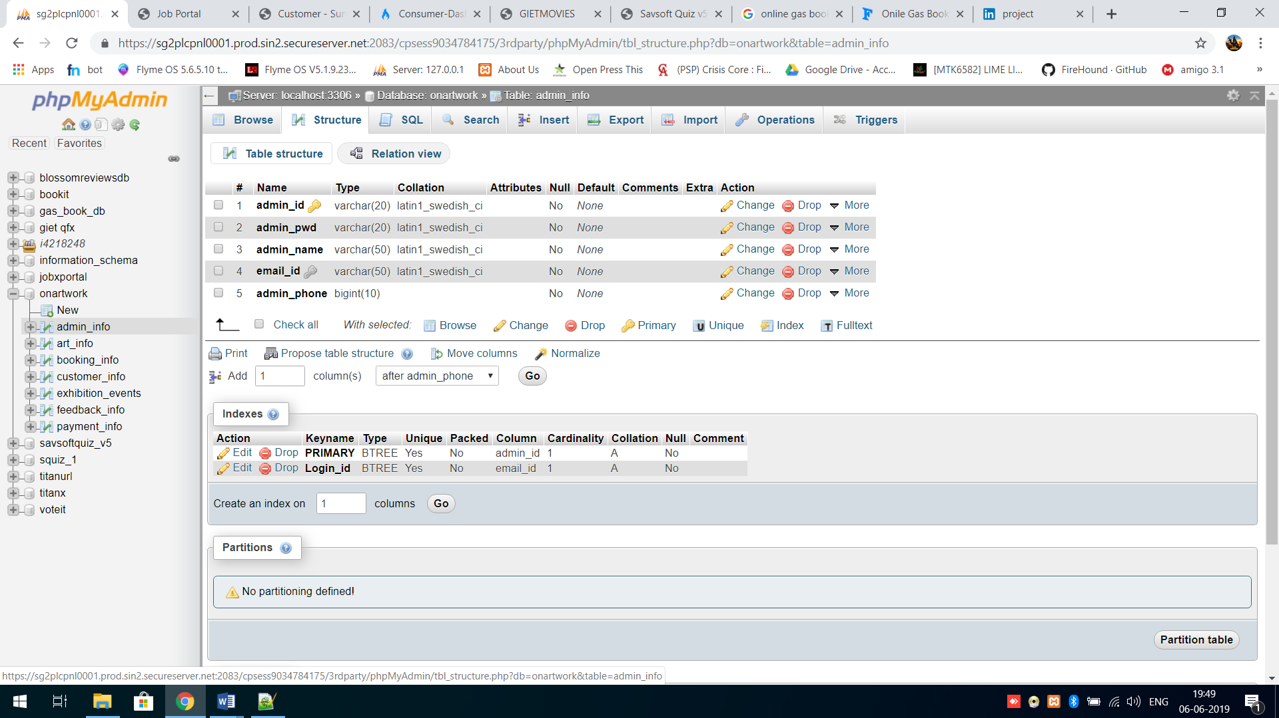

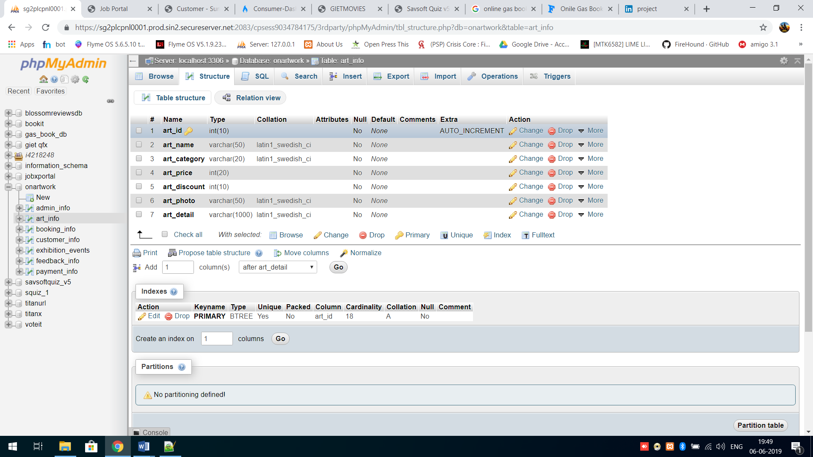

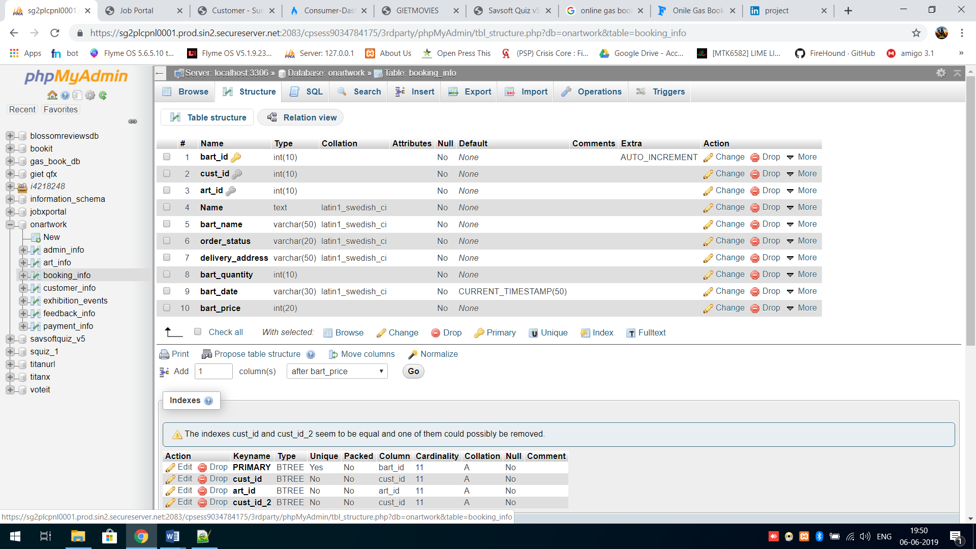

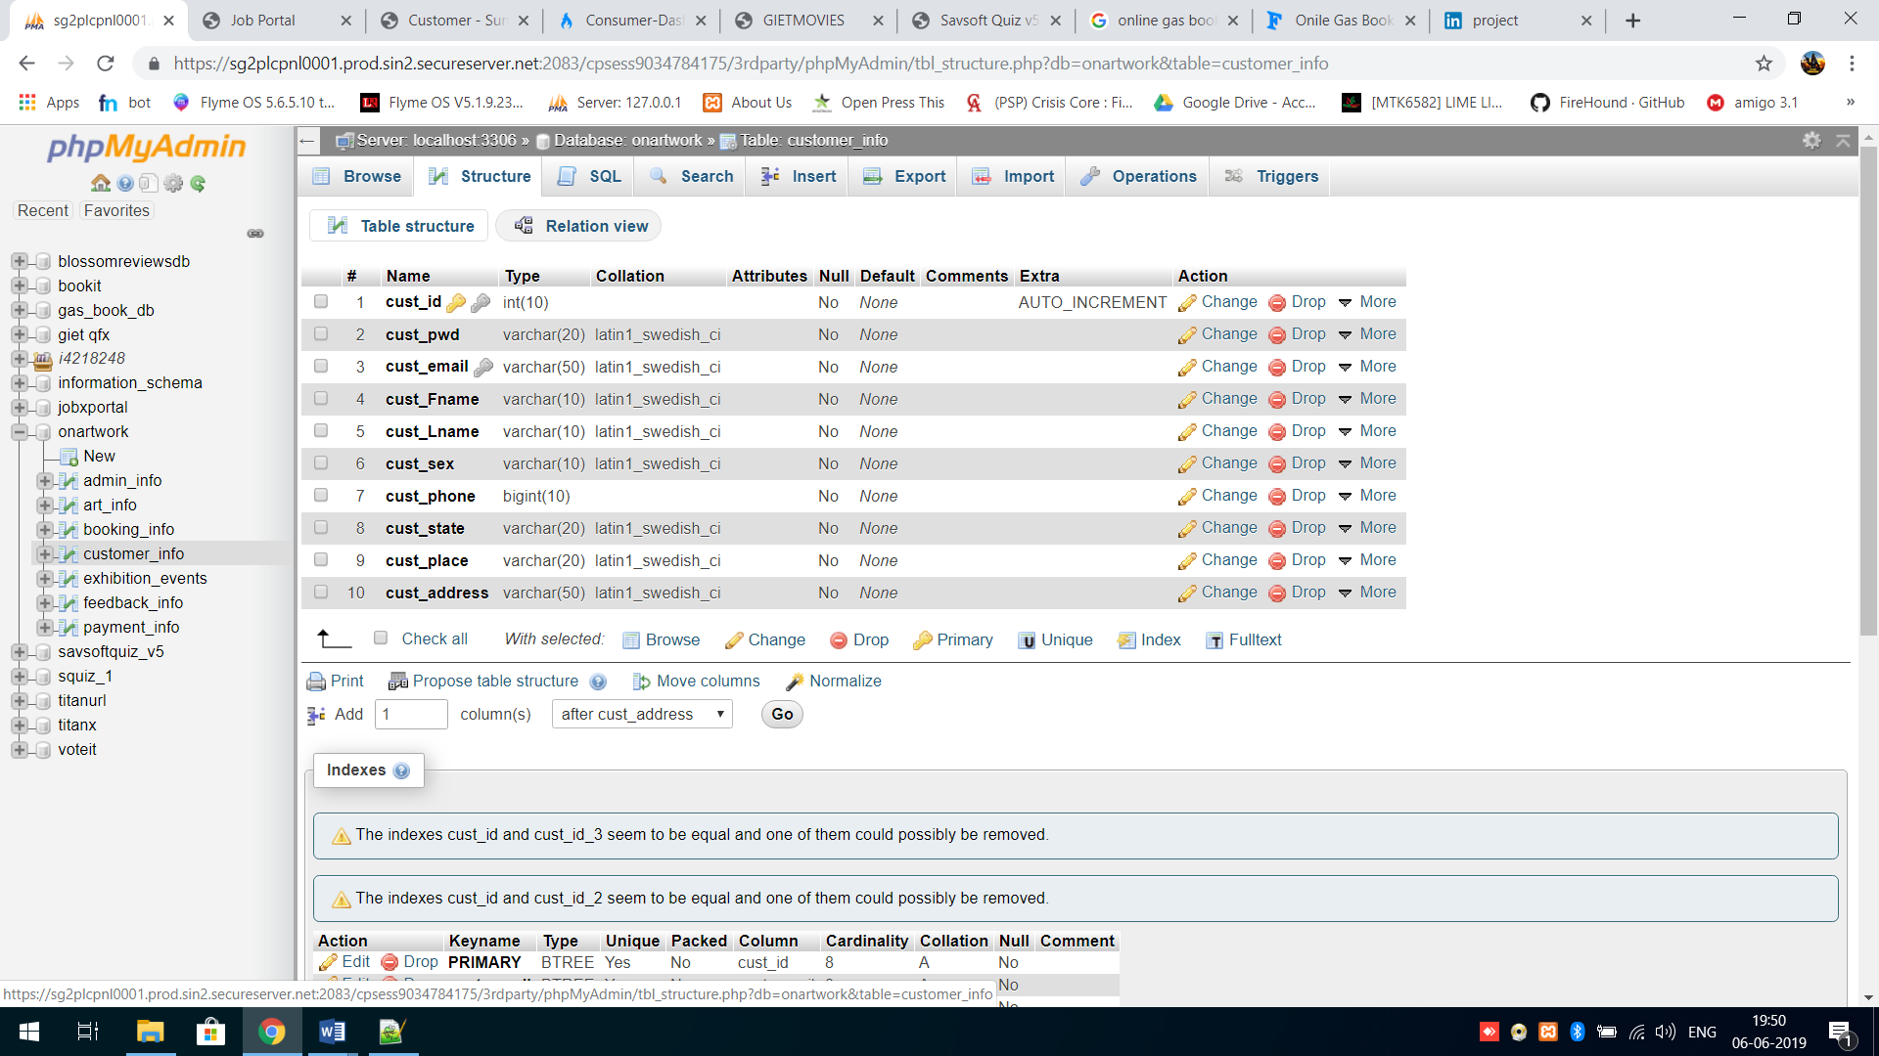

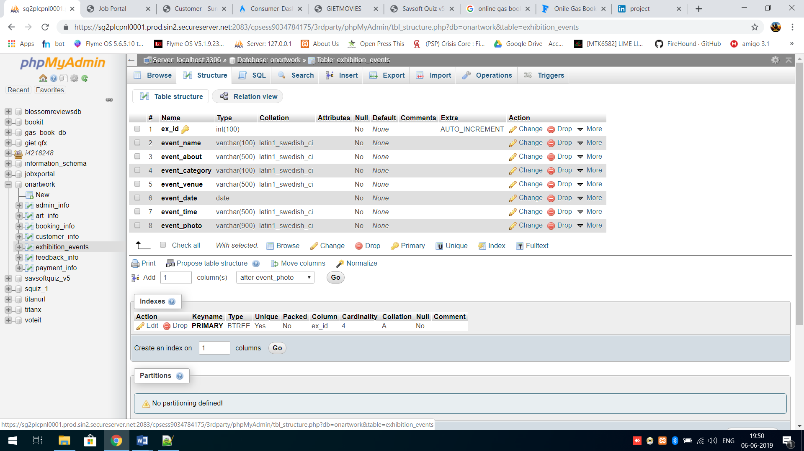

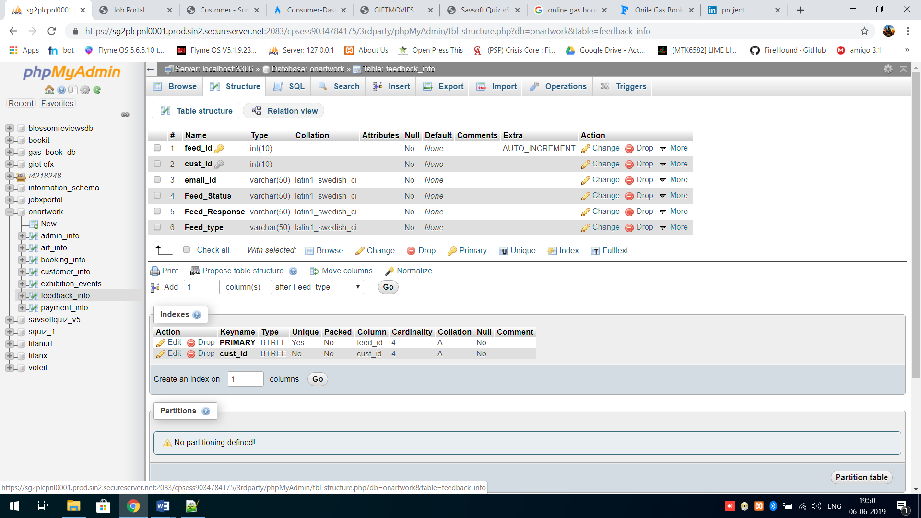

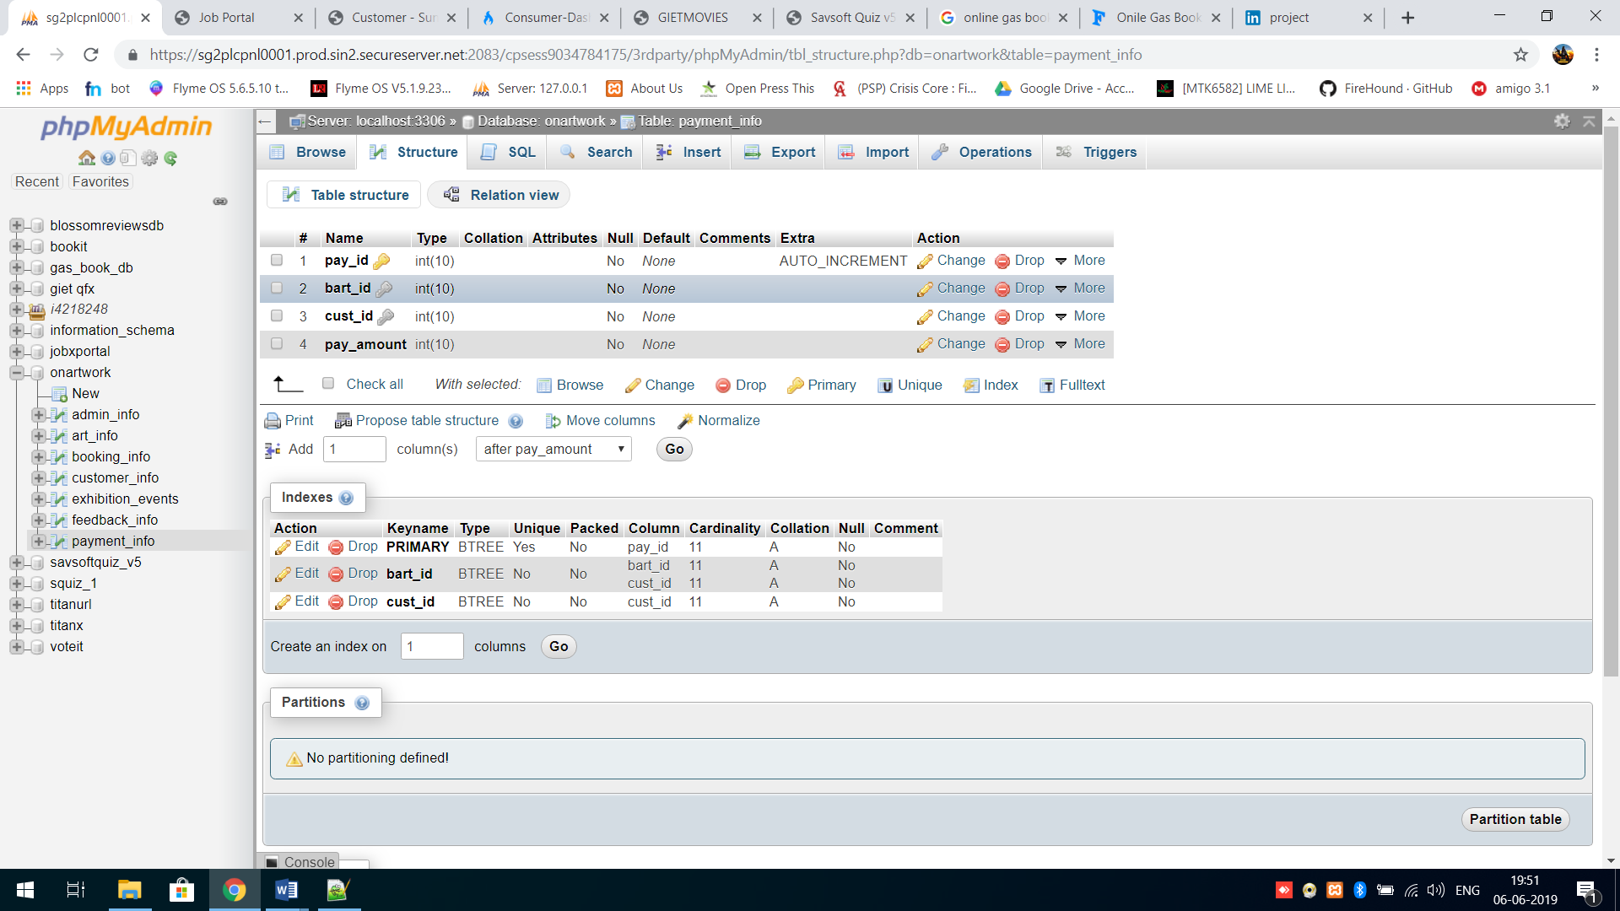

**___________________________**

**DIAGRAM’S**

**___________________________**

**DATA FLOW DIAGRAM**

Login Management

Customer Management

Stock Management

System user Management

Artwork Management

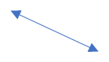

Order Management

**Level Zero DFD**

Artwork Management

Order Report Generation

Login Report Generation

System user Report Generation

Stock Report Generation

Artwork Report Generation

Customer Report Generation

Stock Management

Customer Management

Order Management

System user Management

Login Management

**Level 1 DFD**

**ACTIVITY DIAGRAM**



**ER DIAGRAM**

Login

Is callingng

Art

Booking

As

a

Exhibition

Customer/Admin

Is giving

Payment

Feedback

**___________________________**

**FORM DESIGN**

**___________________________**

**FORM DESIGN**

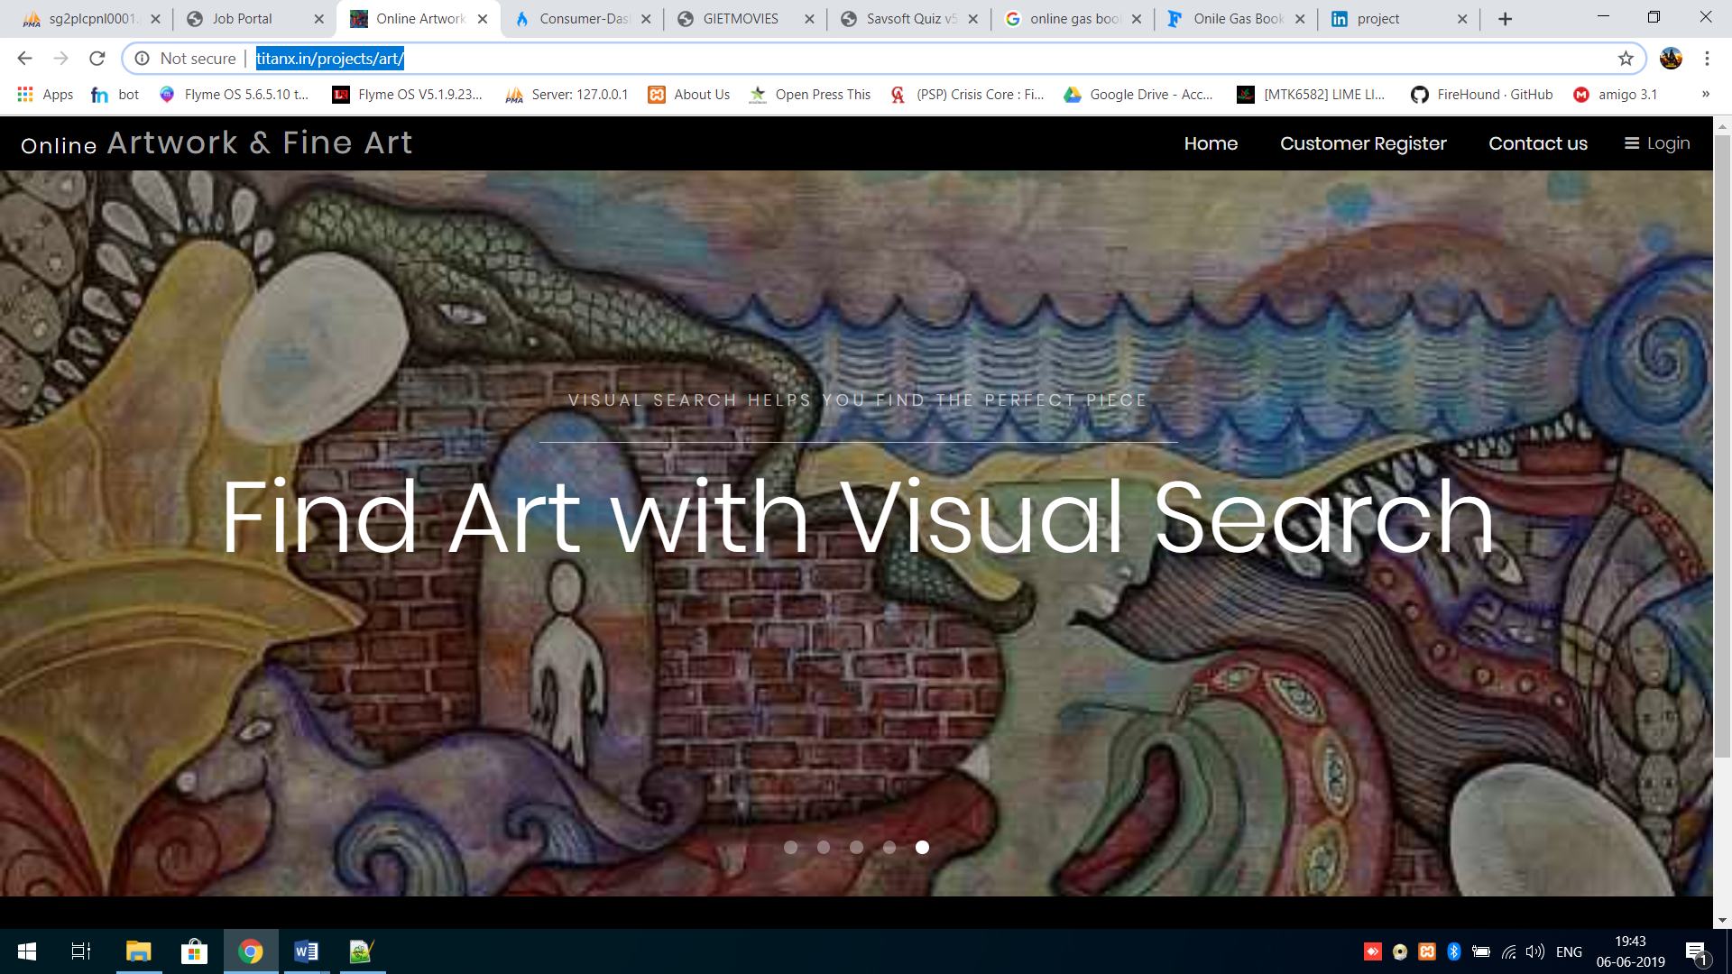

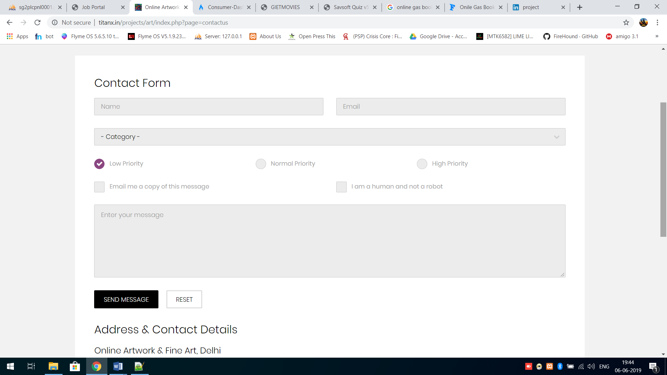

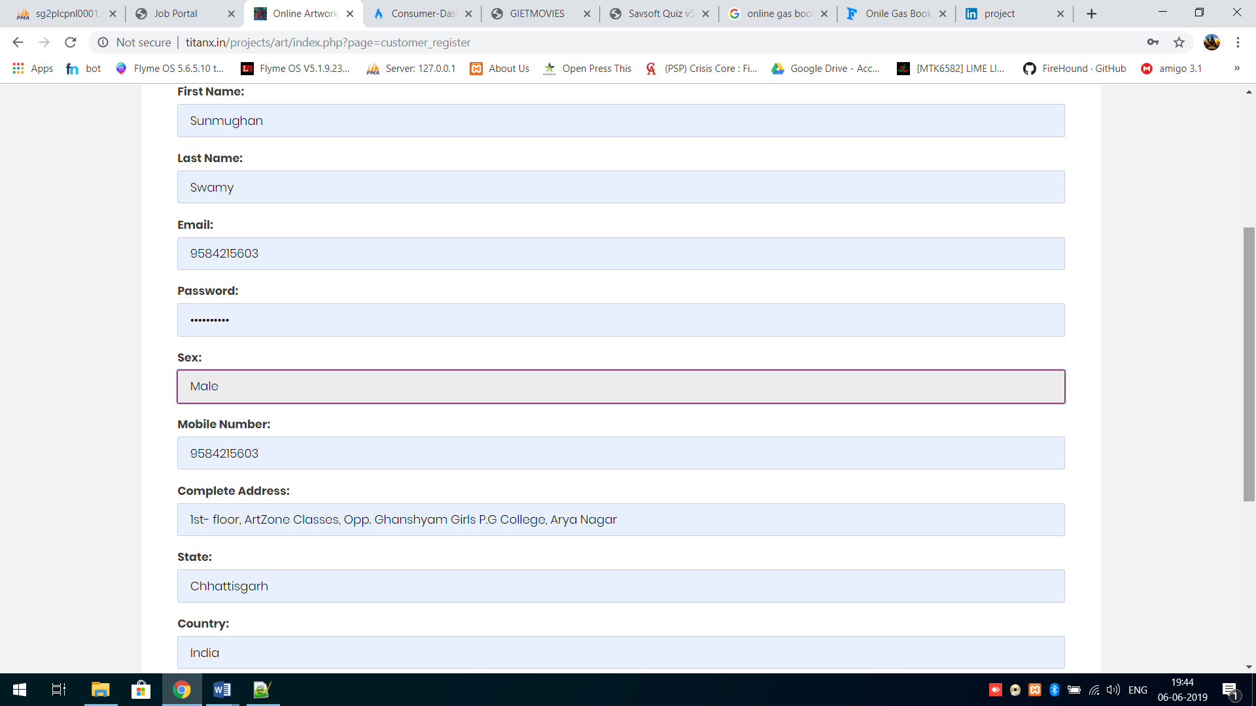

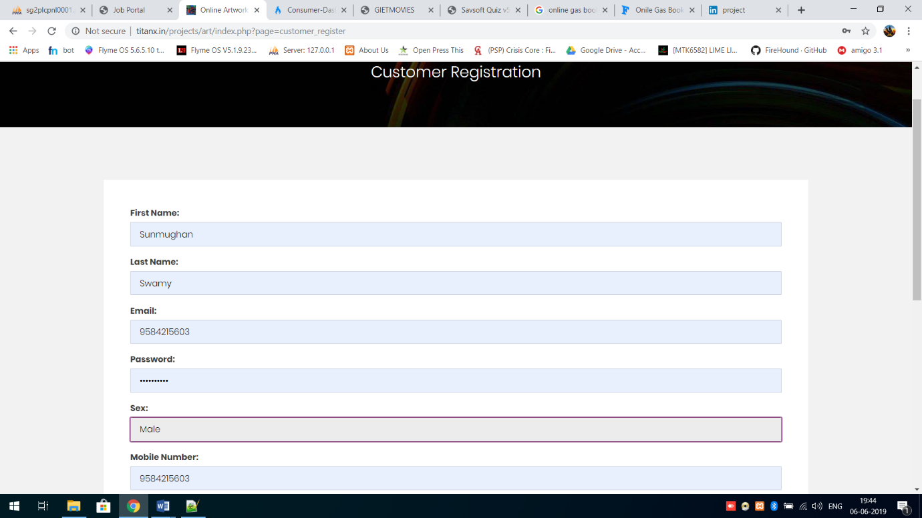

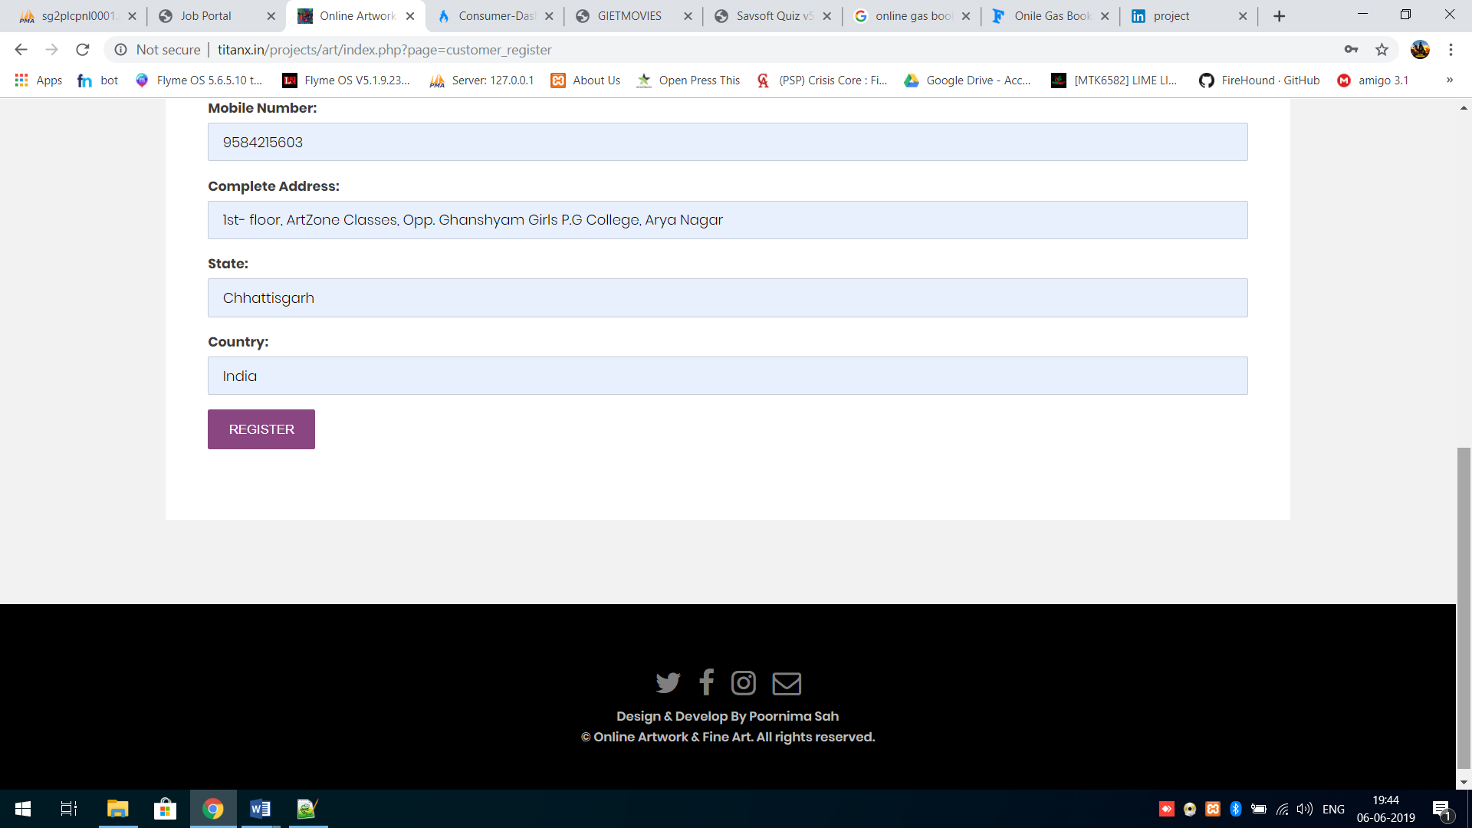

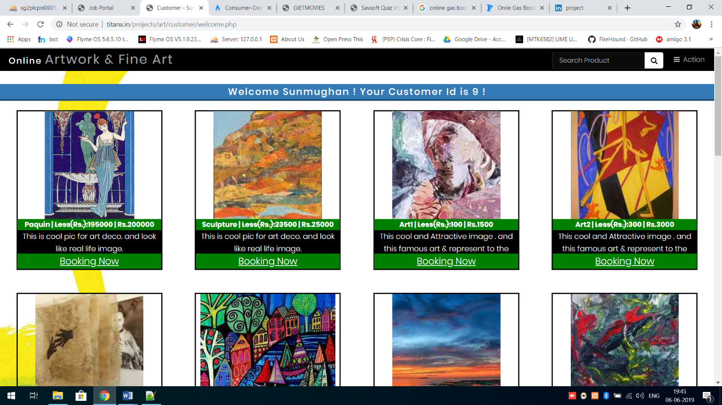

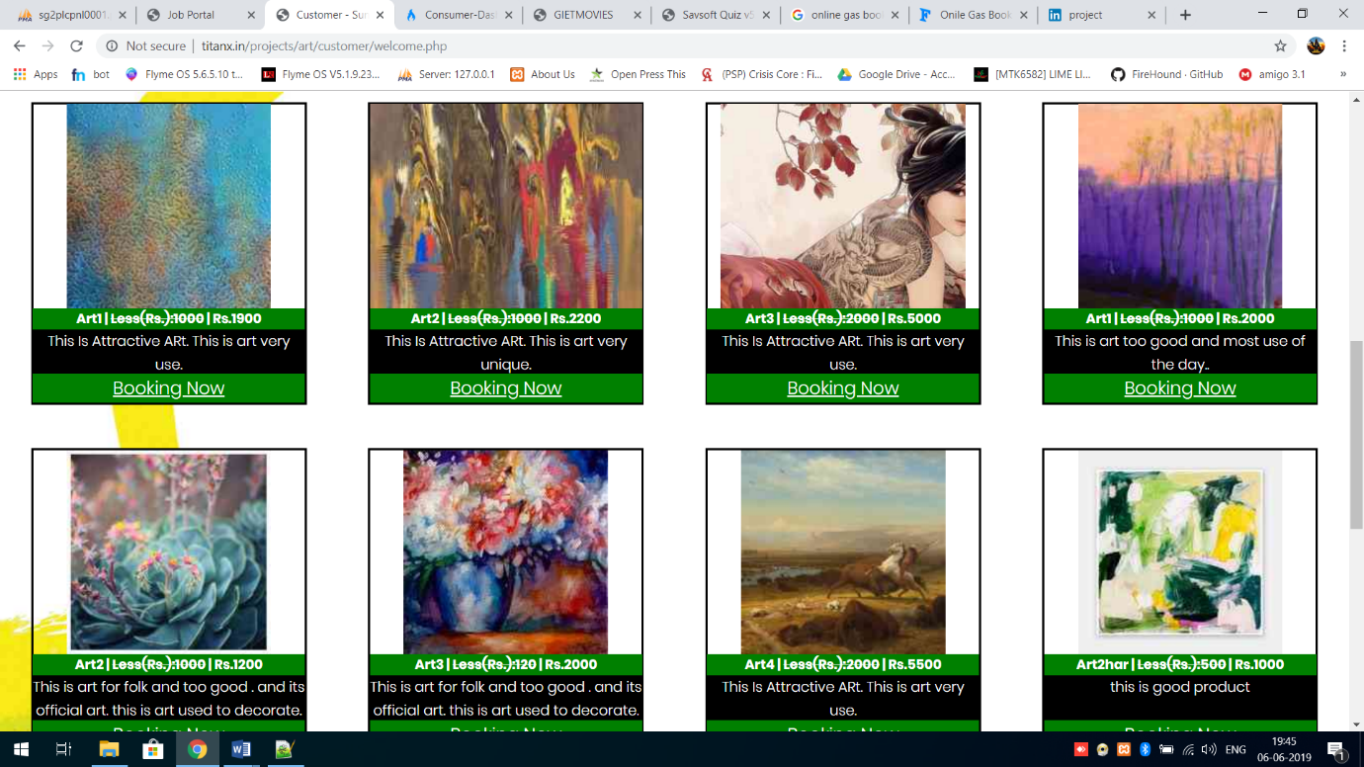

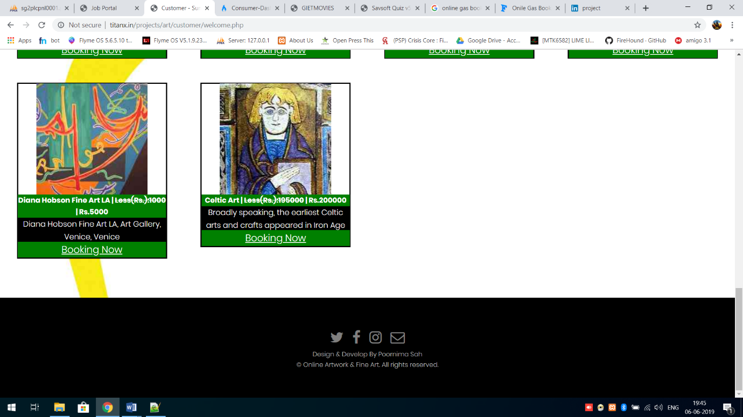

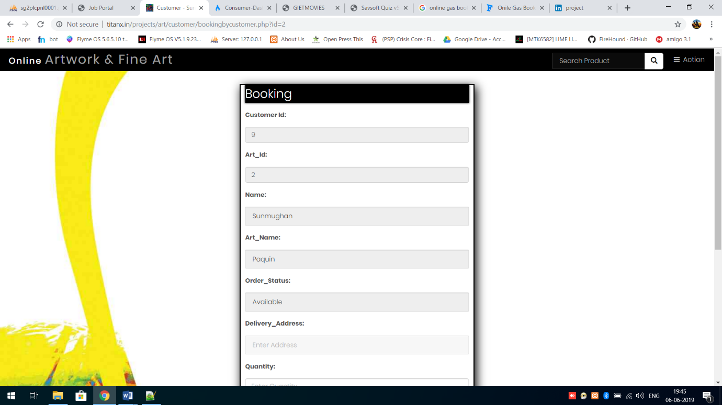

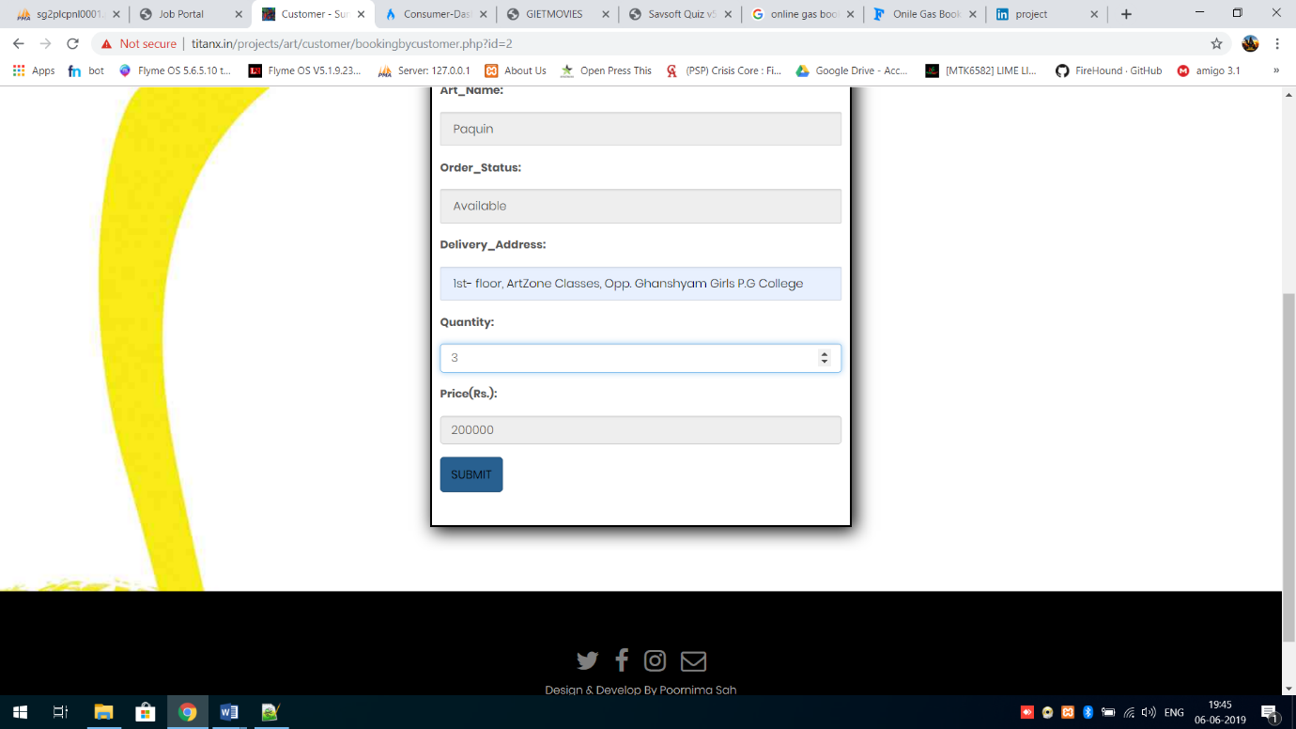

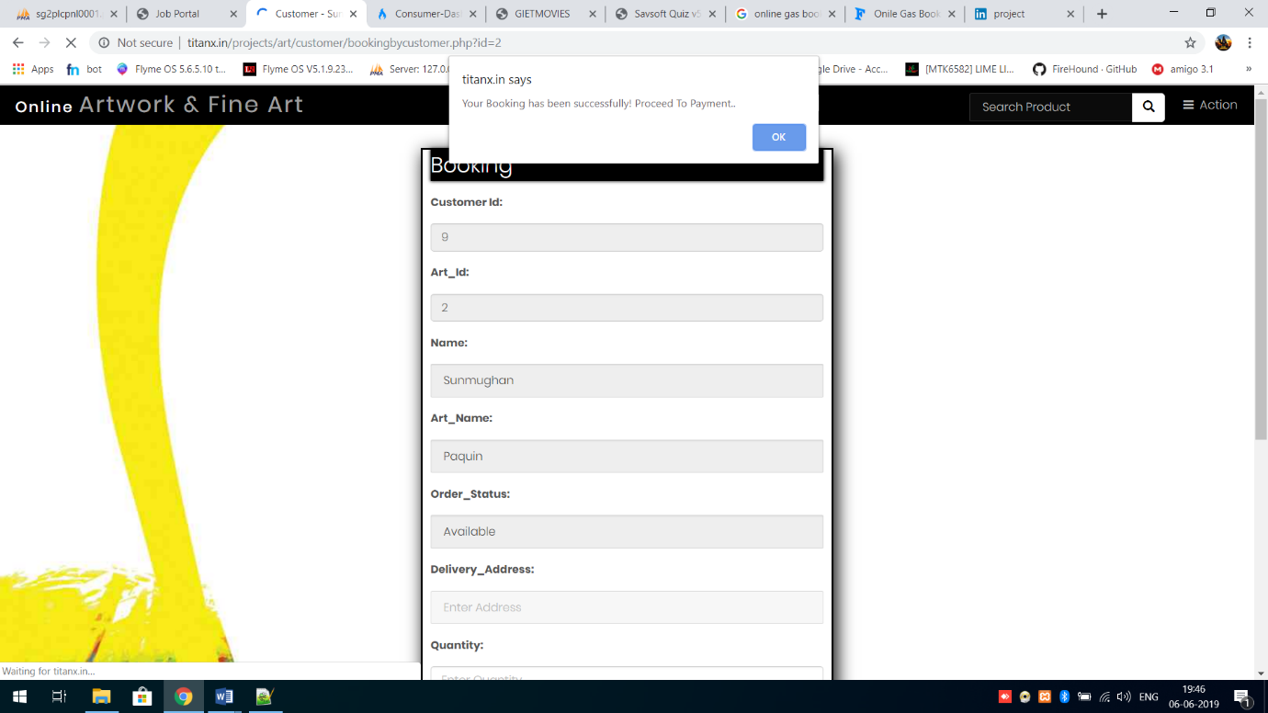

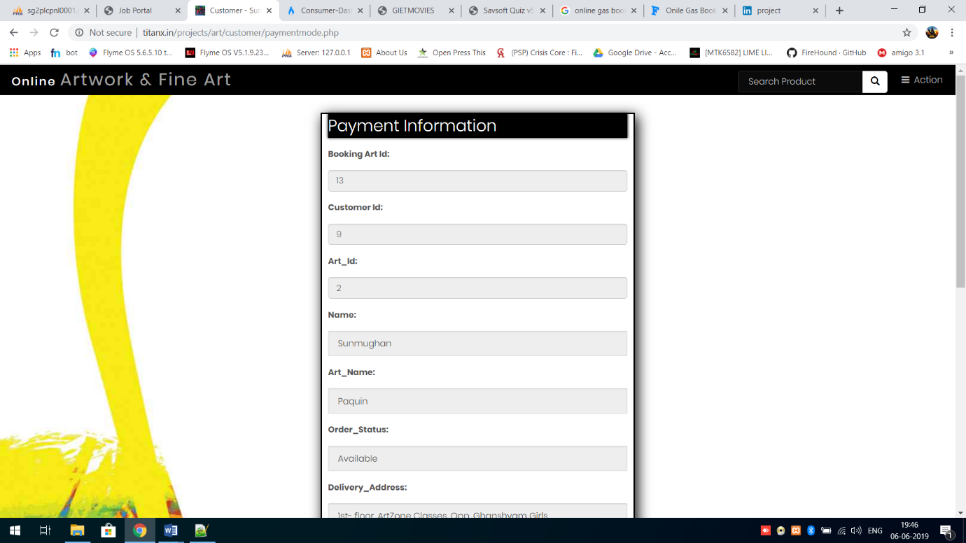

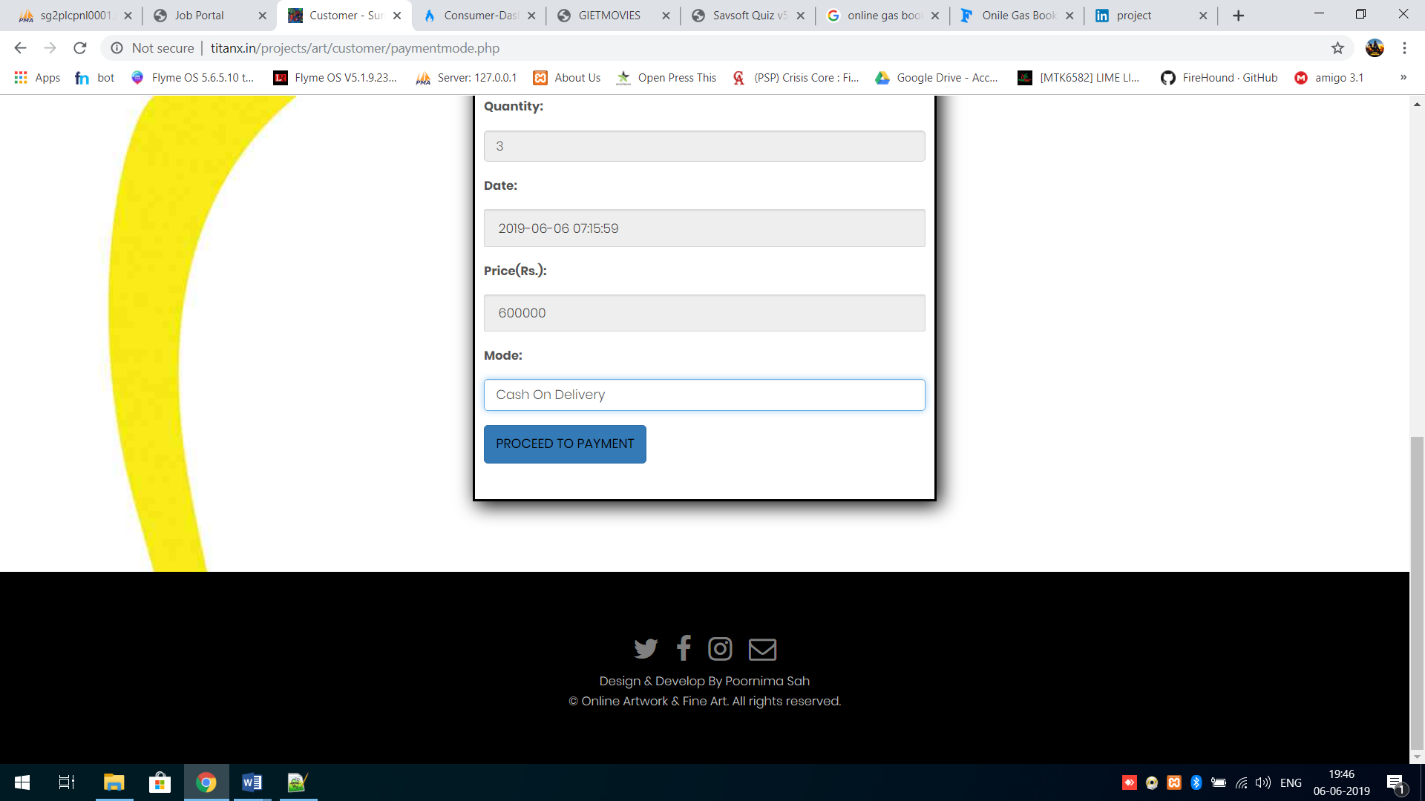

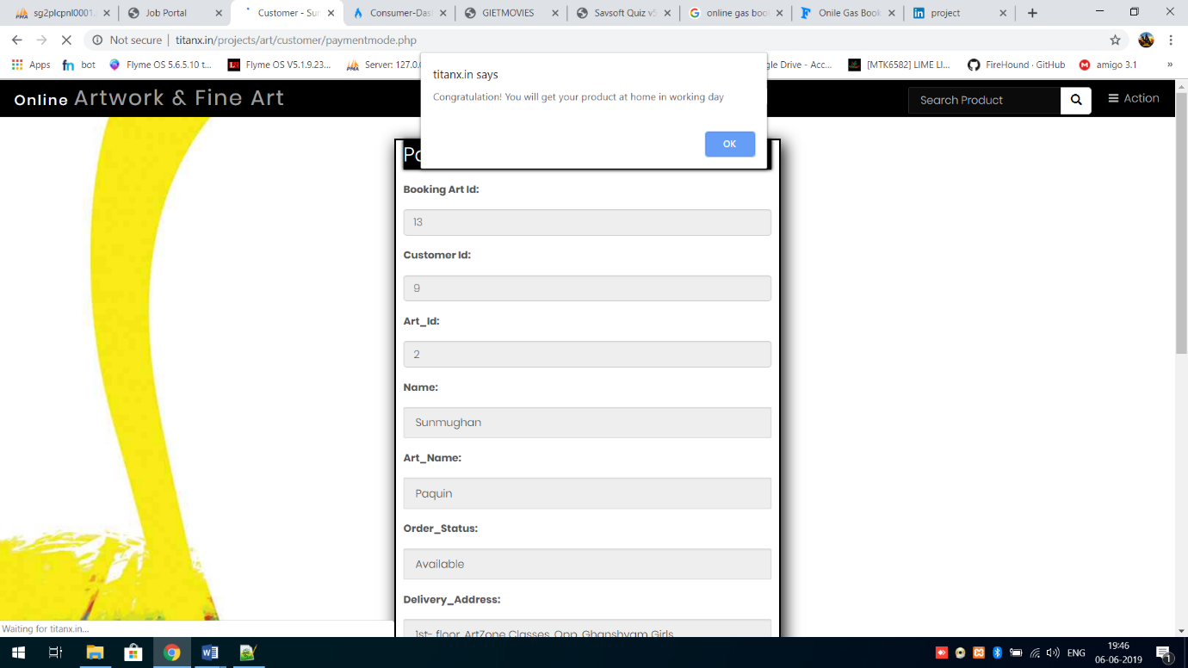

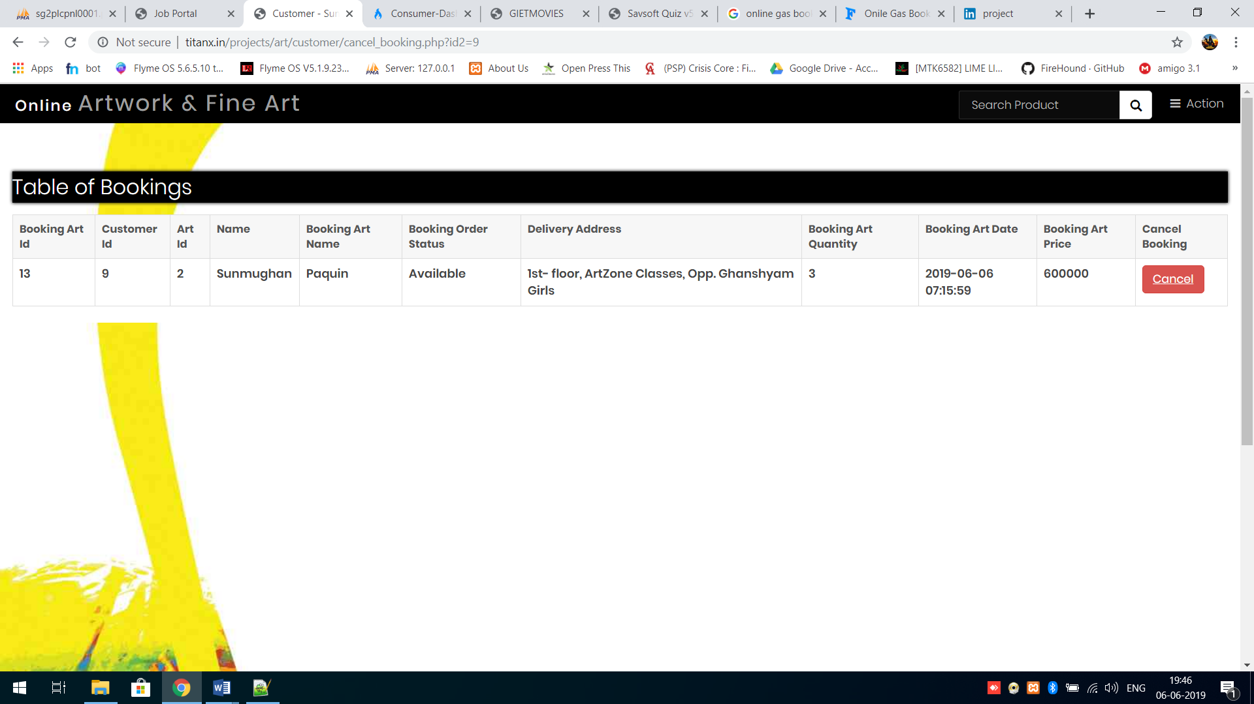

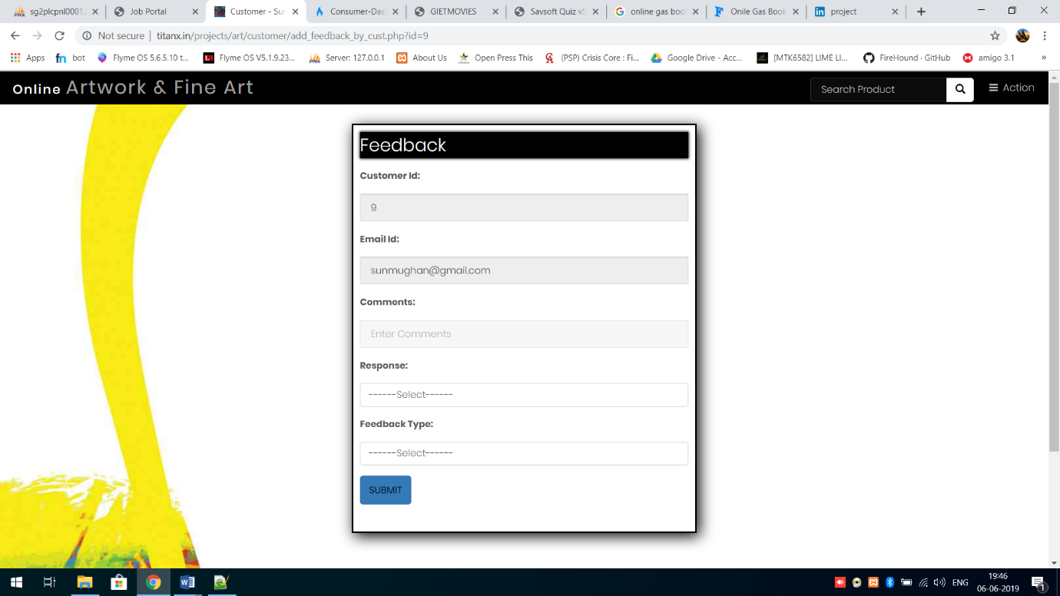

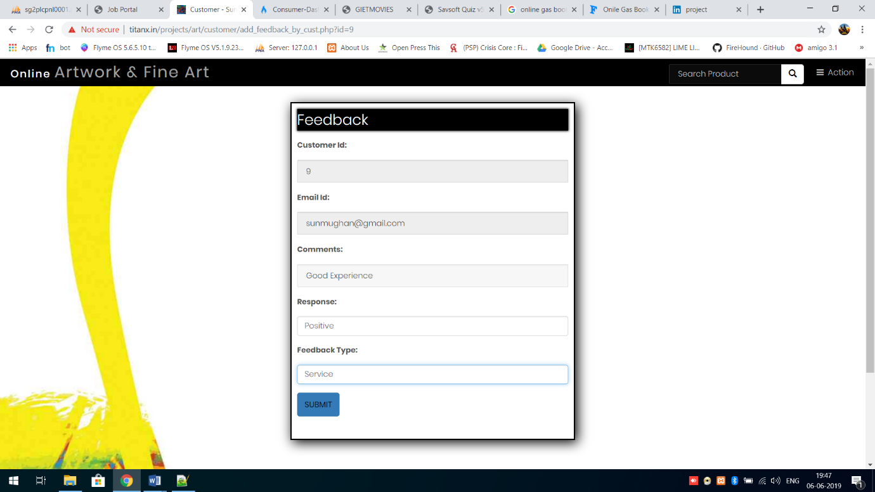

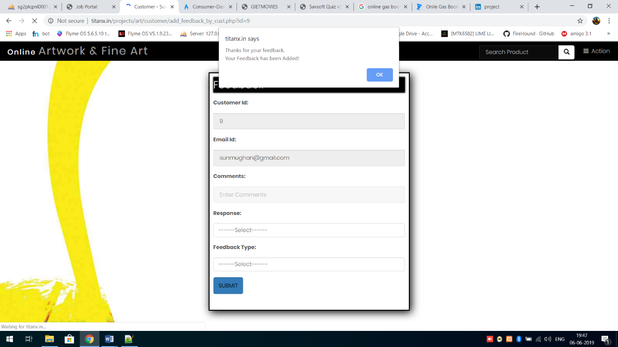

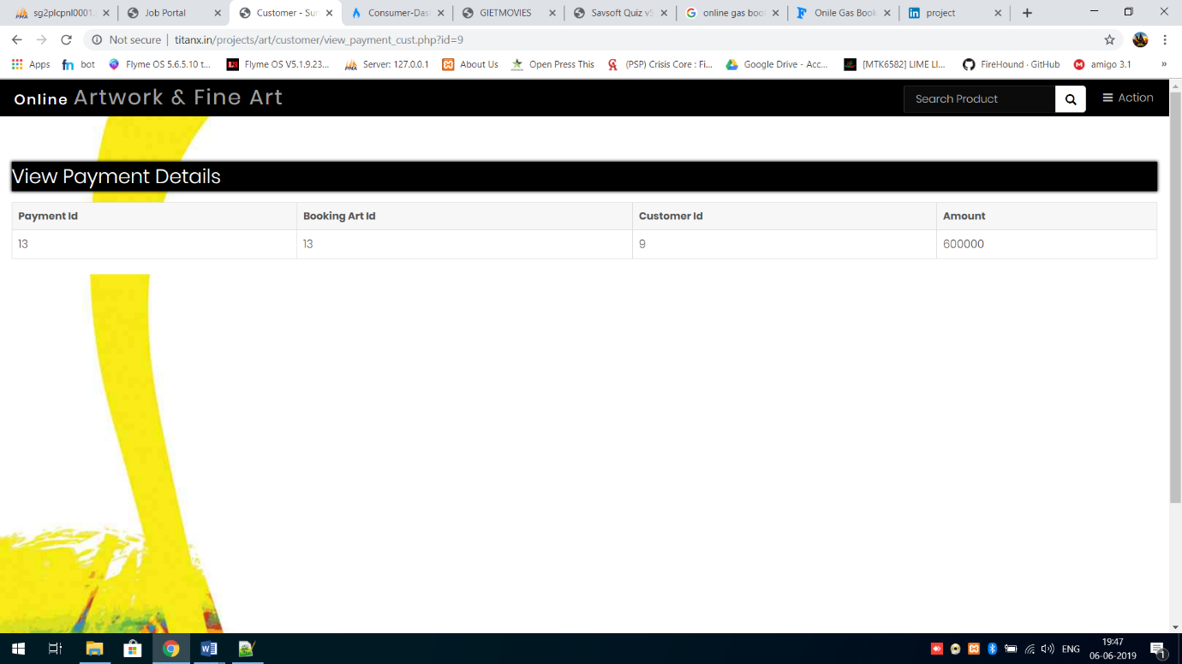

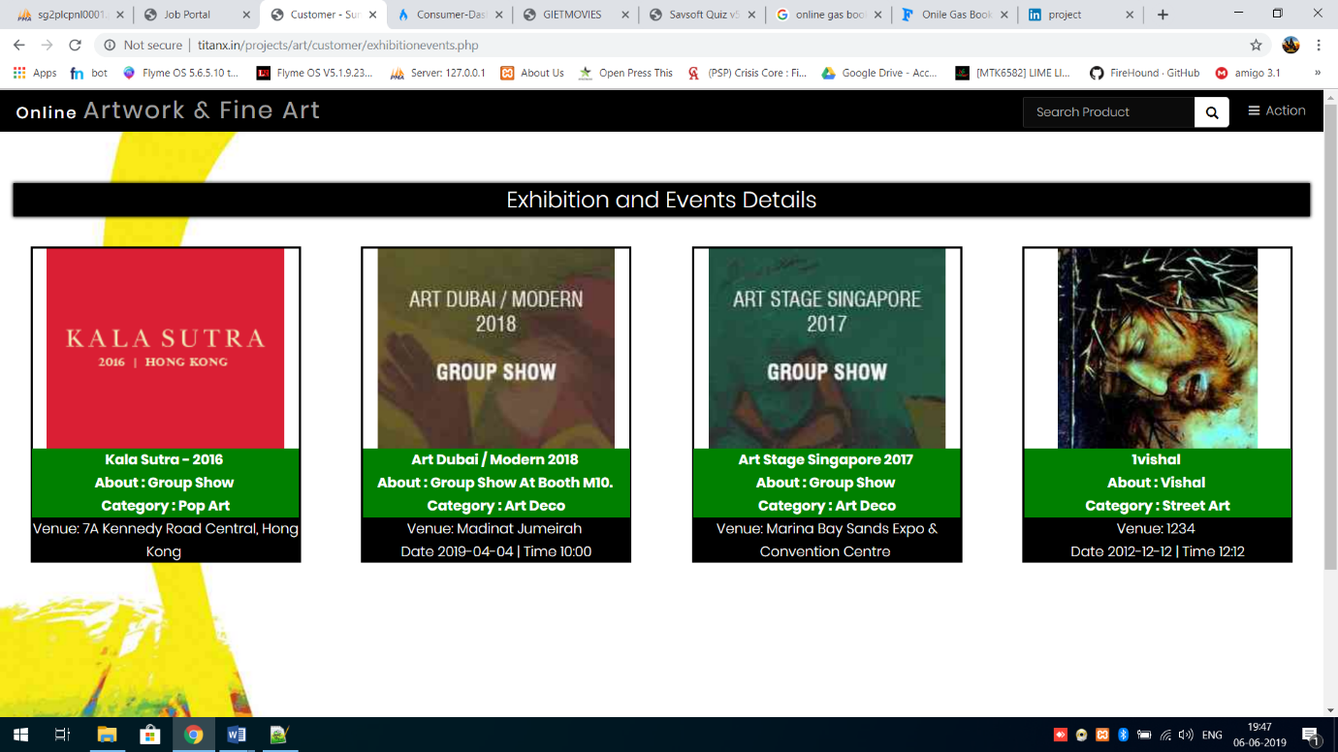

**___________________________**

**FORM CODING**

**___________________________**

**FORM CODING**

1. **Index.php**

<?php

include("connection.php");

session_start(); // Start the session

?>

<!DOCTYPE HTML>

<html>

<head>

<title>Online Artwork & Fine Art</title>

<meta charset="utf-8" />

<meta name="viewport" content="width=device-width, initial-scale=1" />

<link rel="stylesheet" href="assets/css/main.css" />

<link rel="shortcut icon" href="img/favicon.ico" type="image/x-icon">

<link rel="icon" href="img/favicon.ico" type="image/x-icon">

</head>

<body>

<!-- Header -->

<header id="header" class="alt" >

<div class="logo"><a href="index.php">Online <span>Artwork & Fine Art</span></a></div>

<ul class="nav navbar-nav custom-navbar">

<li class="active" ><a href="index.php">Home</a></li>

<li><a href="index.php?page=customer_register">Customer Register</a></li>

<li><a href="index.php?page=contactus">Contact us</a></li>

</ul>

<a href="#menu">

<p class="custom-para">Login</p>

</a>

</header>

<!-- Nav -->

<nav id="menu">

<ul class="links">

<li><a href="index.php?page=customer_login">Customer</a></li>

<li><a href="index.php?page=admin_login">Admin</a></li>

</ul>

</nav>

<section>

<?php

if ( isset( $_GET[ 'page' ] ) ) {

$page_name = $_GET[ 'page' ];

include( "login_register/" . $page_name . ".php" );

} else {

include( "login_register/main.php" );

}

?>

</section>

<!-- Footer -->

<footer id="footer">

<div class="container">

<ul class="icons">

<li><a href="#" class="icon fa-twitter"><span class="label">Twitter</span></a></li>

<li><a href="#" class="icon fa-facebook"><span class="label">Facebook</span></a></li>

<li><a href="#" class="icon fa-instagram"><span class="label">Instagram</span></a></li>

<li><a href="#" class="icon fa-envelope-o"><span class="label">Email</span></a></li>

</ul>

</div>

<div class="copyright">

<div class="footer text-center">Design & Develop By Poornima Sah</div>

&copy; Online Artwork & Fine Art. All rights reserved.

</div>

</footer>

<!-- Scripts -->

<script src="assets/js/jquery.min.js"></script>

<script src="assets/js/jquery.scrollex.min.js"></script>

<script src="assets/js/skel.min.js"></script>

<script src="assets/js/util.js"></script>

<script src="assets/js/main.js"></script>

</body>

</html>

1. **Connection.php**

<?php

// Create connection

$con = mysqli_connect( "localhost", "root", "", "artwork" );

// Check connection

if ( !$con ) {

die( "Connection failed: " . mysqli_connect_error() );

}

?>

1. **Welcome.php (Consumer)**

<div class="back-img back-img1 img-welcome">

<?php include("header/header.php"); ?>

<?php

if($_SESSION["uid"] == "" || $_SESSION["uid"]==NULL)

{

header('Location:../index.php?page=customer_login');

}

else{

$cid =$_SESSION["uid"];

echo "<div class='text-center wel-div'>Welcome " .$_SESSION["name"] ." ! ";

echo "Your Customer Id is " . $cid . " !" . "</div>";

}

?>

<div class="container-fluid">

<div class="row">

<?php

if(isset($_POST['search'])){

echo "<script>

$(document).ready(function(){

$('.alllist').hide();

});

</script>";

$sr=$_POST['proname'];

// display by selected item.

$run=mysqli_query($con, "select * from art_info where art_category='$sr'");

if (mysqli_num_rows($run) >0){

// output data of each row

while($result=mysqli_fetch_array($run))

{

echo "<div class='col-md-3 col-sm-6 productlist'><div style='border: 2px solid #000;margin: 20px;text-align: -webkit-center;'>

<div><img src='$result[5]' style='height:230px;' class='img-responsive'></div>

<div style='background:green;color:#fff;font-size:16px;font-weight:bold;' class='text-center text-capitalize'><span>$result[1] | <span style='text-decoration:line-through;'>Less(Rs.):$result[4]</span> | Rs.$result[3]</span></div><div class='product-des' style='background:#000;color:#fff;font-size: 16px;height:50px;overflow-y:hidden;' class='text-center'><span>$result[6]</span></div><div class='text-center'style='background:green;font-size: 20px;'><a href='bookingbycustomer.php?id=$result[0]' style='color:#fff'>Booking Now</a></div></div></div>";

}

}

else {

echo "<script> window.alert('Not Found ');

window.location.assign('welcome.php');

</script>";

}

}

// all product display

$run=mysqli_query($con, "select * from art_info");

if (mysqli_num_rows($run) >0){

// output data of each row

while($result=mysqli_fetch_array($run))

{

echo "<div class='col-md-3 col-sm-6 alllist productlist'>

<div style='border: 2px solid #000;margin: 20px;text-align: -webkit-center;'>

<div>

<img src='$result[5]' style='height:230px;' class='img-responsive'>

</div>

<div style='background:green;color:#fff;font-size:15px;font-weight:bold;' class='text-center text-capitalize'>

<span>$result[1] | <span style='text-decoration:line-through;'>Less(Rs.):$result[4]</span> | Rs.$result[3]</span></div><div class='product-des' style='background:#000;color:#fff;font-size: 16px;height:50px;overflow-y:hidden;' class='text-center'><span>$result[6]</span></div><div class='text-center'style='background:green;font-size: 20px;'><a href='bookingbycustomer.php?id=$result[0]' style='color:#fff'>Booking Now</a></div></div></div>";

}

}

mysqli_close($con);

?>

</div>

</div>

</div>

<?php include("../footer/footer.php"); ?>

1. **Paymentmethod.php**

<?php include("header/header.php"); ?>

<?php

if($_SESSION["uid"] == "" || $_SESSION["uid"]==NULL)

{

header('Location:index.php?page=customer_login');

}

else{

$cbid = $_SESSION['baid'];

$run_bart=mysqli_query($con,"select * from booking_info where bart_id=$cbid");

$art_result1=mysqli_fetch_array($run_bart);

}

?>

<!--this is form for payment-->

<div class="back-img back-img1">

<div class="container divform">

<h2>Payment Information</h2>

<form action="" method="post" name="f1">

<div class="form-group">

<label for="a11">Booking Art Id:</label>

<input type="number" class="form-control" id="a11" name="bart" placeholder="Enter Id" readonly value="<?php echo $art_result1[0];?>" >

</div>

<div class="form-group">

<label for="a1">Customer Id:</label>

<input type="number" class="form-control" id="a1" name="custid1" placeholder="Enter Id" readonly value="<?php echo $art_result1[1];?>" >

</div>

<div class="form-group">

<label for="a2">Art_Id:</label>

<input type="number" class="form-control" id="a2" name="arid" readonly value="<?php echo $art_result1[2];?>">

</div>

<div class="form-group">

<label for="a3"> Name:</label>

<input type="text" class="form-control" id="a3" name="cname" readonly required value="<?php echo $art_result1[3];?>">

</div>

<div class="form-group">

<label for="a4"> Art_Name:</label>

<input type="text" class="form-control" id="a4" name="aname" readonly value="<?php echo $art_result1[4];?>">

</div>

<div class="form-group">

<label for="a5">Order_Status:</label>

<input type="text" class="form-control" id="a5" name="os" readonly value="<?php echo $art_result1[5];?>">

</div>

<div class="form-group">

<label for="a6">Delivery_Address:</label>

<input type="text" class="form-control" id="a6" name="da" readonly placeholder="Enter Address" required value="<?php echo $art_result1[6];?>">

</div>

<div class="form-group">

<label for="a7">Quantity:</label>

<input type="number" class="form-control" id="a7" name="quan" readonly placeholder="Enter Quantity" required value="<?php echo $art_result1[7];?>">

</div>

<div class="form-group">

<label for="a8">Date:</label>

<input type="text" class="form-control" id="a8" name="date" readonly value="<?php echo $art_result1[8];?>">

</div>

<div class="form-group">

<label for="a9">Price(Rs.):</label>

<input type="text" class="form-control" id="a9" name="price" readonly value="<?php echo $art_result1[9];?>">

</div>

<div class="form-group">

<label for="a10">Mode:</label>

<select class="form-control" name="sel" id="a10" required>

<option value="">---Select--</option>

<option value="Cash On Delivery">Cash On Delivery</option>

</select>

</div>

<button type="submit" class="btn btn-primary" name="sub">Proceed To Payment</button>

</form>

</div>

</div>

<?php include("../footer/footer.php"); ?>

<!--End this is form for payment-->

<?php

if ( isset( $_POST[ 'sub' ] ) ){

$a=$_POST['bart'];

$b=$_POST['custid1'];

$c=$_POST['price'];

$run_pay=mysqli_query($con, "insert into payment_info (bart_id, cust_id, pay_amount) values('$a', '$b', '$c')"); // this is query for payment to insert database.

if($run_pay){

echo "<script> window.alert('Congratulation! You will get your product at home in working day');

window.location.assign('../customer/')

</script>";

}

else{

echo "<script> window.alert('Please try again later.');

window.location.assign('../customer/')

</script>";

}

}

mysqli_close($con);

?>

1. **AddExhibition.php**

<?php include("header/header.php");?>

<!--this is form for add product -->

<section id="One" class="wrapper style3">

<div class="inner">

<header class="align-center">

<p>ADD</p>

<h2>Exhibition & Events Details</h2>

</header>

</div>

</section>

<section id="two" class="wrapper style2">

<div class="content" style="overflow-x:auto">

<div class="back-img back-img1">

<div class="container divform">

<h2>Add Exhibition & Events</h2>

<form action="" method="post" name="f1" enctype="multipart/form-data">

<div class="form-group">

<label for="artnm">Name</label>

<input type="text" class="form-control" id="artnm" name="a1" placeholder="Enter Name of Exhibition & Events " required>

</div>

<div class="form-group">

<label for="artnm">About</label>

<textarea rows="6" type="text" class="form-control" id="a2" name="a2" placeholder="Enter About of Exhibition & Events " required></textarea>

</div>

<div class="form-group">

<label for="sel1">Category of Exhibition & Events</label>

<select class="form-control" id="sel1" name="a3" required>

<option value="">------Select ------</option>

<option value="Art Deco">

Art Deco

</option>

<option value="Fine Art">

Fine Art

</option>

<option value="Folk">

Folk

</option>

<option value="Pop Art">

Pop Art

</option>

<option value="Street Art">

Street Art

</option>

</select>

</div>

<div class="form-group">

<label for="pr">Venue</label>

<input type="text" class="form-control" id="pr" name="a4" placeholder="Enter Venue of Exhibition & Events " required>

</div>

<div class="form-group">

<label for="dis">Date</label>

<input type="date" class="form-control" id="dis" name="a5" placeholder="Enter Date of Exhibition & Events " required>

</div>

<div class="form-group">

<label for="dis">Time</label>

<input type="time" class="form-control" id="dis" name="a6" placeholder="Enter Time of Exhibition & Events " required>

</div>

<div class="form-group">

<label for="ph">Photo of Exhibition & Events</label>

<input type="file" class="form-control" id="a7" name="uploadedimage" required>

</div>

<br/>

<button type="submit" class="btn btn-primary" name="sub">Submit</button>

</form>

</div>

</div>

<?php include( "../footer/footer.php" );?>

<?php

if ( isset( $_POST[ 'sub' ] ) ){

$a11=$_POST['a1'];

$a12=$_POST['a2'];

$a13=$_POST['a3'];

$a14=$_POST['a4'];

$a15=$_POST['a5'];

$a16=$_POST['a6'];

function GetImageExtension($imagetype)

{

if(empty($imagetype)) return false;

switch($imagetype)

{

case 'image/bmp': return '.bmp';

case 'image/gif': return '.gif';

case 'image/jpeg': return '.jpg';

case 'image/png': return '.png';

default: return false;

}

}

if (!empty($_FILES["uploadedimage"]["name"]))

{

$file_name=$_FILES["uploadedimage"]["name"];

$temp_name=$_FILES["uploadedimage"]["tmp_name"];

$imgtype=$_FILES["uploadedimage"]["type"];

$ext= GetImageExtension($imgtype);

$imagename=date("d-m-Y")."-".time().$ext;

$target_path = "../img/eventimages/".$imagename;

if(move_uploaded_file($temp_name, $target_path))

{

echo "image success";

}

else

{

echo "error";

}

}

$sql = "INSERT INTO exhibition_events (event_name, event_about, event_category, event_venue, event_date, event_time, event_photo) VALUES ('$a11', '$a12', '$a13', '$a14', '$a15', '$a16','$target_path')"; // this is an insert query for add product

if (mysqli_query($con, $sql)) {

echo "<script>alert('Your Exhibition & Events has been added!');

window.location.assign('add_exhibitionevents.php')

</script>";

} else {

echo "Error: " . $sql . "<br>" . mysqli_error($con);

}

}

mysqli_close($con);

?>

</div>

</section>

**___________________________**

**CONCLUSION**

**___________________________**

**CONCLUSION**

The project entitled **Online Artwork Booking** was completed successfully.

The system has been developed with much care and free of errors and at the same time it is efficient and less time consuming. The purpose of this project was to develop a web application for booking movie tickets from a theatre.

This project helped us in gaining valuable information and practical knowledge on several topics like designing web pages using html & css, usage of responsive templates, , and management of database using mysql . The entire system is secured. Also the project helped us understanding about the development phases of a project and software development life cycle. We learned how to test different features of a project.

This project has given us great satisfaction in having designed an application which can be implemented to any nearby theatres running various kinds of movies by simple modifications.

**___________________________**

**BIBLOGRAPHY**

**___________________________**

**REFERENCES**

JavaScript Enlightenment,Cody Lindley-First Edition, based on JavaScript 1.5, ECMA-262, Editio

Complete CSS Guide ,Maxine Sherrin and John Allsopp-O'Reilly

Media; September 2012

* http://www.w3schools.com/html/defualt.asp,
* http://www.w3schools.com/css/default.asp,
* <http://www.w3schools.com/js/default.asp>,
* <http://www.w3schools.com/php/default.asp>,
* http://www.w3schools.com/bootstrap/default.asp